**HTML bgcolor Attribute**

Last Updated : 28 Aug, 2024

**HTML bgcolor attribute** is used to set the background color of an HTML element. Bgcolor is one of those attributes that has become deprecated with the implementation of Cascading Style Sheets (see [CSS](https://www.geeksforgeeks.org/css/) Backgrounds). It accepts color names, hexadecimal color codes, or RGB values to customize the background appearance of the specified element. In modern web development, styling, including background color is typically handled using CSS properties rather than HTML attributes.

***Note:*** *The bgcolor attribute is not supported in HTML5.*

**Syntax**

<"tag" bgcolor="color_name | hex_value | rgb_value">

**Attribute Values**

| **Attribute Values** | **Description** |
| --- | --- |
| **color_name** | It sets the background color by using the color name. For example “red”. |
| **hex_number** | It sets the background color by using the color hex code. For example “#0000ff”. |
| **rgb_number** | It sets the background color by using the RGB code. For example: “RGB(0, 153, 0)”. |

**Supported tags**

| **Tag** | **Description** |
| --- | --- |
| [<body>](https://www.geeksforgeeks.org/html-body-tag/) | Contains content visible to users. |
| [<marquee>](https://www.geeksforgeeks.org/html-marquee-tag/) | Scrolls text or images within a container. |
| [<table>](https://www.geeksforgeeks.org/html-table-bgcolor-attribute/) | Organizes data into rows and columns. |
| [<tbody>](https://www.geeksforgeeks.org/html-tbody-tag/) | Encloses main content rows within a table. |
| [<td>](https://www.geeksforgeeks.org/html-td-tag/) | Represents data cells within a table row. |
| [<tfoot>](https://www.geeksforgeeks.org/html-tfoot-tag/) | Defines a footer section within a table. |
| [<th>](https://www.geeksforgeeks.org/html-th-tag/) | Indicates header cells within a table row. |
| [<thead>](https://www.geeksforgeeks.org/html-thead-tag/) | Contains header rows within a table. |
| [<tr>](https://www.geeksforgeeks.org/html-tr-tag/) | Represents a table row, containing data or headers. |
| [<col>](https://www.geeksforgeeks.org/html-col-tag/) | Defines properties for one or more table columns. |
| [<colgroup>](https://www.geeksforgeeks.org/html-colgroup-tag/) | Groups one or more columns in a table for styling. |

**Example 1:** In this example, the table’s background color is set to green using the bgcolor attribute.



1

<!DOCTYPE html>

2

<html>

3

​

4

<head>

5

<title>

6

HTML table bgcolor Attribute

7

</title>

8

</head>

9

​

10

<body>

11

<h1>GeeksforGeeks</h1>

12

​

13

<h2>HTML table bgcolor Attribute</h2>

14

​

15

<table border="1" bgcolor="green">

16

<caption>

17

Author Details

18

</caption>

19

​

20

<tr>

21

<th>NAME</th>

22

<th>AGE</th>

23

<th>BRANCH</th>

24

</tr>

25

<tr>

26

<td>BITTU</td>

27

<td>22</td>

28

<td>CSE</td>

29

</tr>

30

<tr>

31

<td>RAM</td>

32

<td>21</td>

33

<td>ECE</td>

34

</tr>

35

</table>

36

</body>

37

​

38

</html>

**Output:**

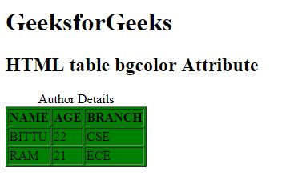

**Example 2:** In this example, the bgcolor attribute within the <body> tag is used to set the background color of the entire page to orange.



1

<!DOCTYPE html>

2

<html>

3

​

4

<head>

5

<title>

6

HTML body Bgcolor Attribute

7

</title>

8

</head>

9

​

10

<!-- body tag starts here -->

11

​

12

<body text="green" bgcolor="orange">

13

<center>

14

<h1>GeeksforGeeks</h1>

15

<h2>

16

HTML

17

body bgcolor Attribute

18

</h2>

19

​

20

<p>

21

It is a Computer

22

Science portal For Geeks

23

</p>

24

​

25

</center>

26

</body>

27

<!-- body tag ends here -->

28

​

29

</html>

**Output:**

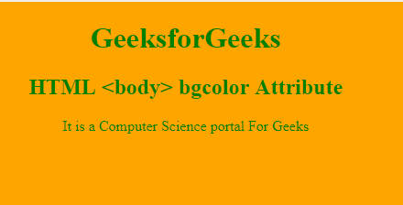

**Supported Browsers:**

* [Google Chrome](https://www.geeksforgeeks.org/google-chrome-browser/)
* [Edge](https://www.geeksforgeeks.org/microsoft-edge-browser/)
* [Firefox](https://www.geeksforgeeks.org/mozilla-firefox-browser/)
* [Opera](https://www.geeksforgeeks.org/opera-browser/)
* [Safari](https://www.geeksforgeeks.org/apple-safari-browser/)

**HTML bgcolor Attribute F**